 |  |  | Czech Metrology Institute, ILC Department  Okružní 772/31, 638 00 Brno, Czech Republic  Tel.: +420 545 555 157
77

2
0
2
ILC PROGRAM IDEAS FOR:
 |  |  | Be a co-author of our ILC programs which can be useful for your laboratory. |  |  |  | 
QUANTITY |  |  | MEASURING INSTRUMENT | RANGE |  | FURTHER SPECIFICATION
 |  |  | 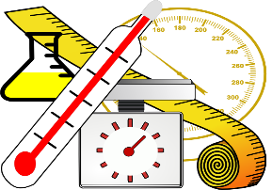 | 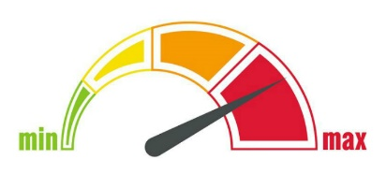 |  | 

1
2
3
4
5
6
7
 | FURTHER IDEAS AND COMMENTS:

 |  | This completed form is to be sent to the email address: |  |  | sklenovska@cmi.gov.cz
 |  | The latest deadline for submitting the form: |  |  | 30.09.2026
 |  | 

