Calibrations by Master Scanner XP 10060
Length laboratory of CMI Regional Inspectorate Brno is newly equipped with the measuring instrument Master Scanner XP 10060, manufactured by IAC Geometrische Ingenieurs B.V., designed specifically for calibrations of thread gauges.
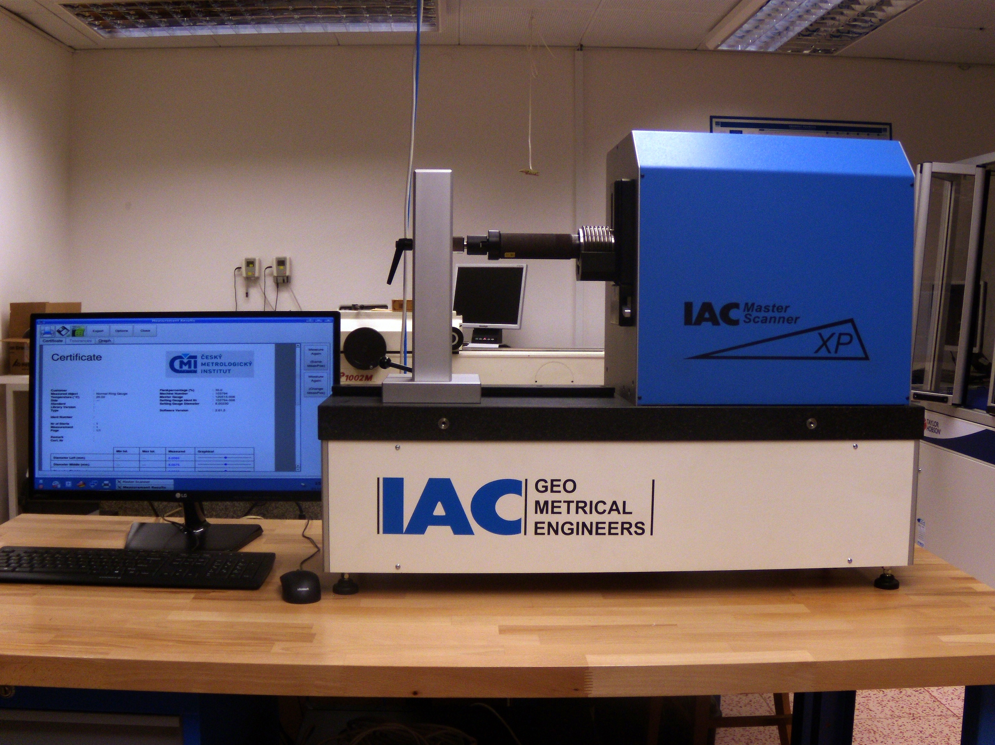 | 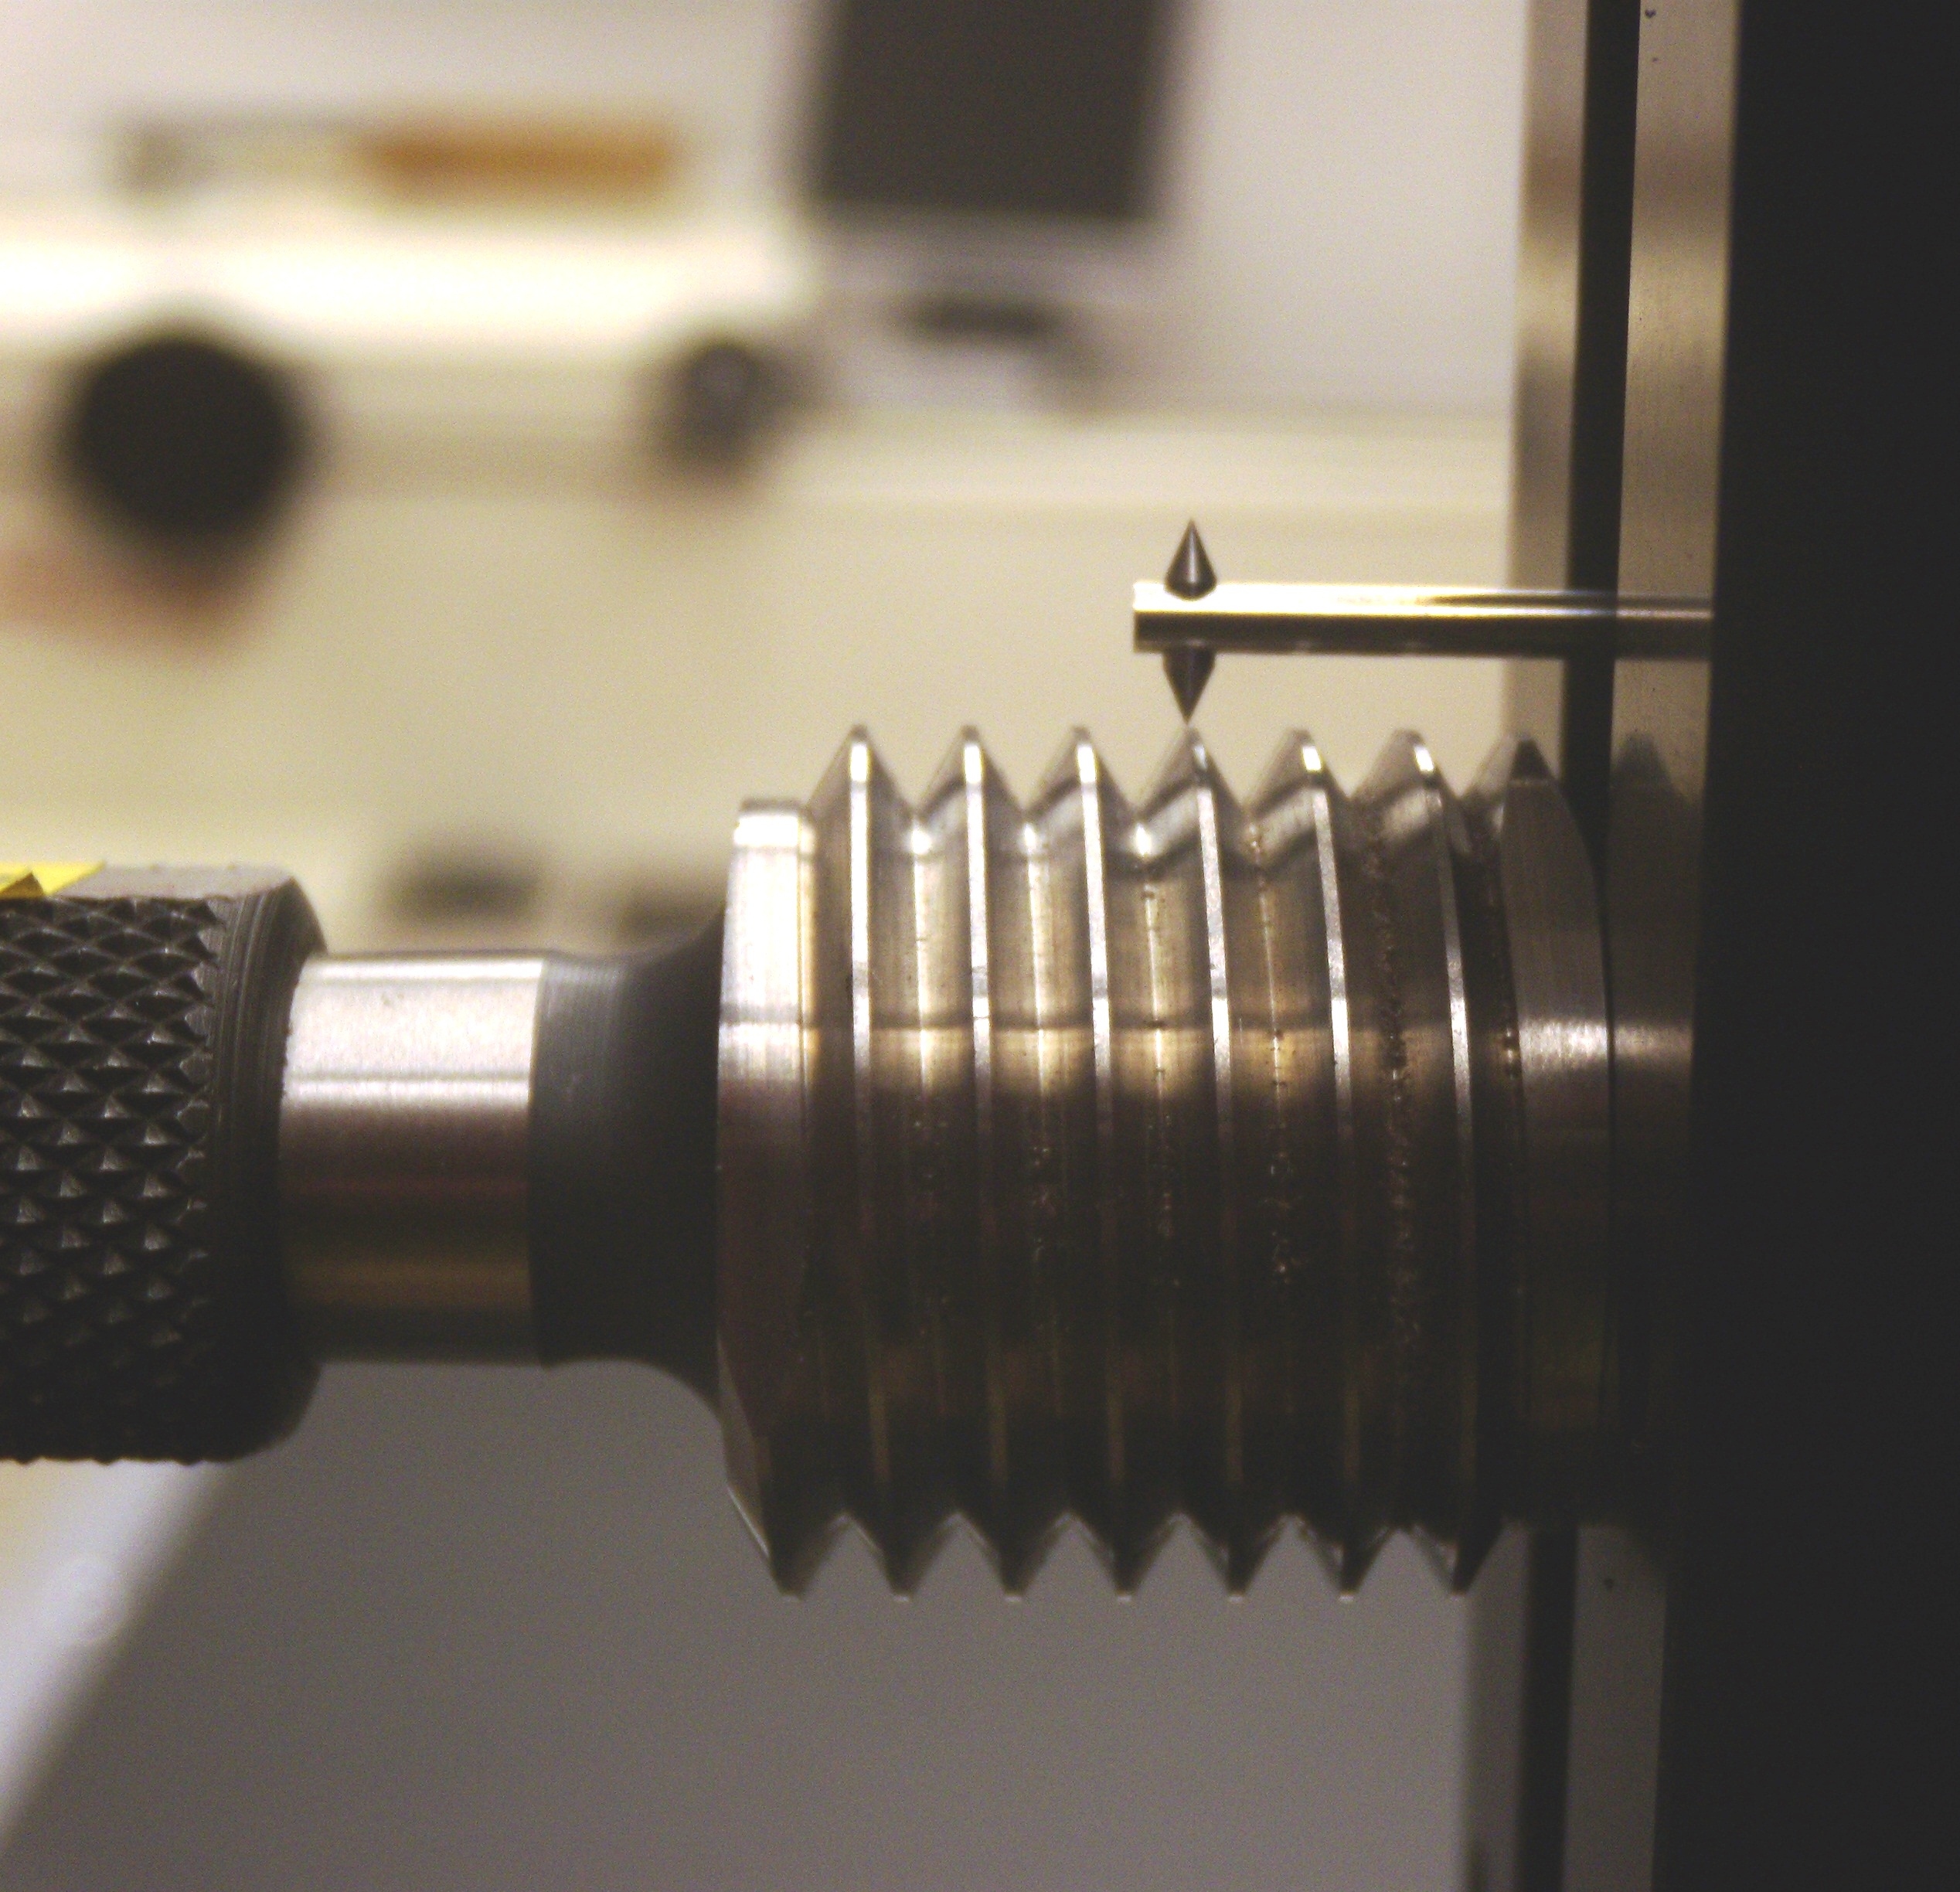
The principle of measurement of the instrument consists in mechanical scanning of the thread profile. Unlike traditional methods based on measuring wires or balls, the Master Scanner evaluates the thread profile and all the thread parameters.
Main disadvantages of methods using measuring wires or balls:
- only the simple pitch diameter is evaluated
- the result of measurement is affected by the real diameter of wires or balls
- the result of measurement is affected by real thread profile
- there are difficulties in measurements of very small gauges or gauges with a small pitch
- difficulties with measurements of tapered gauges
Main advantages of measuring by Master Scanner XP 10060:
- all the thread parameters are evaluated (pitch diameter, minor diameter, major diameter, pitch, flank angle)
- the pitch diameter is evaluated taking into account the real thread profile by definition
- the scanning probe with a small tip radius enables measurements of even very small pitches
- measurements of tapered gauges are possible
Measurement of all the thread parameters is explicitly recommended at least for the first calibration - see for example VDI/VDE/DGQ, 2618 part 4.8 and 4.9.
Measurement range of Master Scanner XP 10060:
Internal diameter: (2.5 ÷ 100) mm
External diameter: (1.0 ÷ 90) mm
In case of interest in such calibrations please contact:
Ing. Václav Duchoň
tel.: + 420 545 555 207
e-mail: vduchon@cmi.cz

