EMPIR Partnering Meeting

Time and place:
Wednesday 28th June – Thursday 29th June 2017

Czech Metrology Institute, TESTCOM Praha, Hvožďanská Street 2053/3,

148 00 Prague, Czech Republic

Hosting: Czech Metrology Institute, Prague, Czech Republic

Wednesday 28th June 2017
From 8:00 | Registration: All Delegates (2nd floor, building C)  Please register early.
9:30 – 11:30 | Welcome and introduction. A training session on EMPIR projects for all interested parties will be given by the MSU.
11:45 – 12:45 | Lunch (CMI cafeteria, 2nd floor, building C)
13:00 – 17:00 | SRT discussions in various meeting rooms:
13:00 – 17:00 | building A, 2nd floor, room no. 201 | SRT-n07 Thermal conductivity measurement of Super Insulating Materials and measurement uncertainty reduction
13:00 – 17:00 | building A, 2nd floor, room no. 202 | SRT-i29 Industrial process optimisation through improved metrology of thermophysical properties
13:00 – 17:00 | building A, 2nd floor, room no. 203 | SRT-f13 Accurate atomic and molecular interactions for thermophysical standards
13:00 – 17:00 | building B, 2nd floor, room no. 200 | SRT-f12 Self-calibrating photodiodes for the radiometric linkage to fundamental constants
13:00 – 17:00 | building B, 5th floor, room no. 500 | SRT-n01 Improved traceability chain of nanoparticle size measurements
13:00 – 17:00 | building C, 2nd floor, room no. 200 | SRT-f02 Single-photon sources as new quantum standards
13:00 – 17:00 | building D, 5th floor, room no. 501 | SRT-n05 Metrology for assessing Energy Performance of Buildings under operating conditions
13:00 – 17:00 | building D, 5th floor, room no. 502 | SRT-n08 Determination of thermal resistance by means of guarded hot plate method up to 850 °C
13:00 – 17:00 | building D, 5th floor, room no. 503 | SRT-n02 Advancing measurement uncertainty - comprehensive examples for key international standards
19:00 – ......... | Dinner (CMI cafeteria, 2nd floor, building C, available from 18:30, closing time 23:00)

Thursday 29th June 2017
9:00 – 12:15 | SRT discussions in various meeting rooms
12:30 – 13:30 | Lunch (CMI canteen, 2nd floor, building C)
The rooms will be available till 17:00 | SRT discussions in various meeting rooms

Others:
Contact person:
Ms. Karolína Weberová – kweberova@cmi.cz
phone: 00420 271 192 321
GSM: 00420 736 181 135
Other:
https://msu.euramet.org/calls.html
Map of CMI buildings:
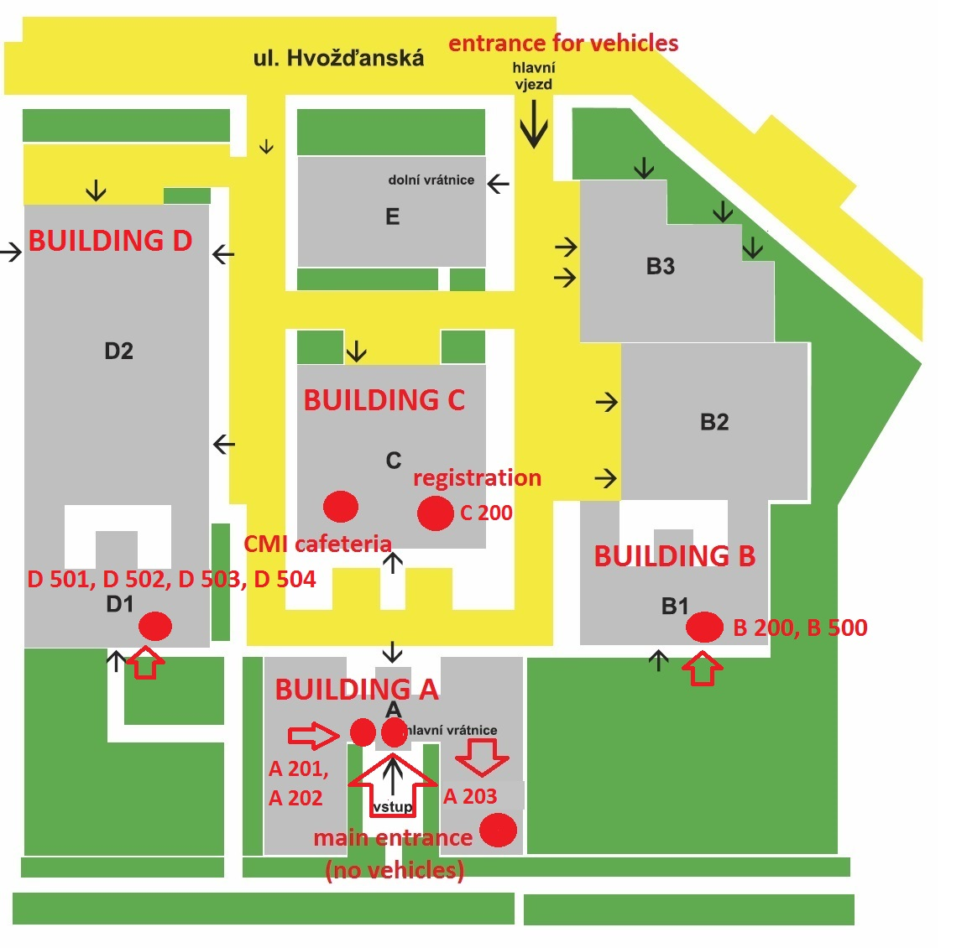
How to get to CMI
From the Václav Havel Airport Praha – two possibilities
- take the bus (special airport line) to the stop Hlavní nádraží (main train station), then cross to the metro (line C) and go to the stop Roztyly (direction Háje)
- take the bus no. 119 and go to the stop Nádraží Veleslavín, then take the metro there and go to the stop Muzeum (line A, direction Depo Hostivař), in Muzeum cross to the metro line C and go to the stop Roztyly (direction Háje)
Fare one way 32 CZK which is approximately 1,2 Eur.
By subway – from the main train station
If the participants arrive at the main train station (Hlavní Nádraží), they should take metro (line C, direction Háje) and go again to the stop Roztyly.
Fare one way 32 CZK which is approximately 1,2 Eur.
Accommodation
There are two hotels within approximately 15 minutes walking distance from the CMI:
Hotel Globus
Top Hotel
The hotels Top Hotel and Globus and also the building of CMI are situated within approximately 10 minutes walking of the metro stop Roztyly.
If the participants will stay at Top Hotel, it is slightly better to go one more metro stop from Roztyly called Chodov (metro line C).

