EMPIR Partnering Meeting

Time and place:
Monday 26th June – Tuesday 27th June 2017

Czech Metrology Institute, TESTCOM Praha, Hvožďanská Street 2053/3,

148 00 Prague, Czech Republic

Hosting: Czech Metrology Institute, Prague, Czech Republic

Monday 26th June 2017
From 8:00 | Registration: All Delegates (2nd floor, building C)  Please register early.
9:30 – 11:30 | Welcome and introduction. A training session on EMPIR projects for all interested parties will be given by the MSU.
11:45 – 12:45 | Lunch (CMI cafeteria, 2nd floor, building C)
13:00 – 17:00 | SRT discussions in various meeting rooms:
13:00 – 17:00 | building A, 2nd floor, room no. 201 | SRT-i01 Metrology for portable emissions measurement systems
13:00 – 17:00 | building A, 2nd floor, room no. 202 | SRT-i21 Co-ordinated metrology to support a European test and certification infrastructure for quantum cryptography
13:00 – 17:00 | building A, 2nd floor, room no. 203 | SRT-i28 Enhancing process efficiency through improved temperature measurement 2
13:00 – 17:00 | building B, 2nd floor, room no. 200 | SRT-f11 Metrology for broadband ro-vibrational spectroscopic thermometry
13:00 – 17:00 | building B, 5th floor, room no. 500 | SRT-i23 Metrology for Manufacturing, Installing and Characterising Smart Lighting
13:00 – 17:00 | building C, 2nd floor, room no. 200 | SRT-i14 Metrology for cosmetic industry products
13:00 – 17:00 | building D, 5th floor, room no. 501 | SRT-i18 Translational metrology for synthetic biology and the manufacturing capability of the 4th industrial revolution
13:00 – 17:00 | building D, 5th floor, room no. 502 | SRT-f01 Large-scale statistical data analysis and computation for metrology
13:00 – 17:00 | building D, 5th floor, room no. 503 | SRT-i17 Metrology for Airborne Molecular Contaminants II
19:00 – ......... | Dinner (CMI cafeteria, 2nd floor, building C, available from 18:30, closing time 23:00)

Tuesday 27th June 2017
9:00 – 12:15 | SRT discussions in various meeting rooms
12:30 – 13:30 | Lunch (CMI canteen, 2nd floor, building C)
The rooms will be available till 17:00 | SRT discussions in various meeting rooms

Contacts:
Contact person:
Ms. Karolína Weberová – kweberova@cmi.cz
phone: 00420 271 192 321
GSM: 00420 736 181 135
Other:
https://msu.euramet.org/calls.html
Map of CMI buildings:
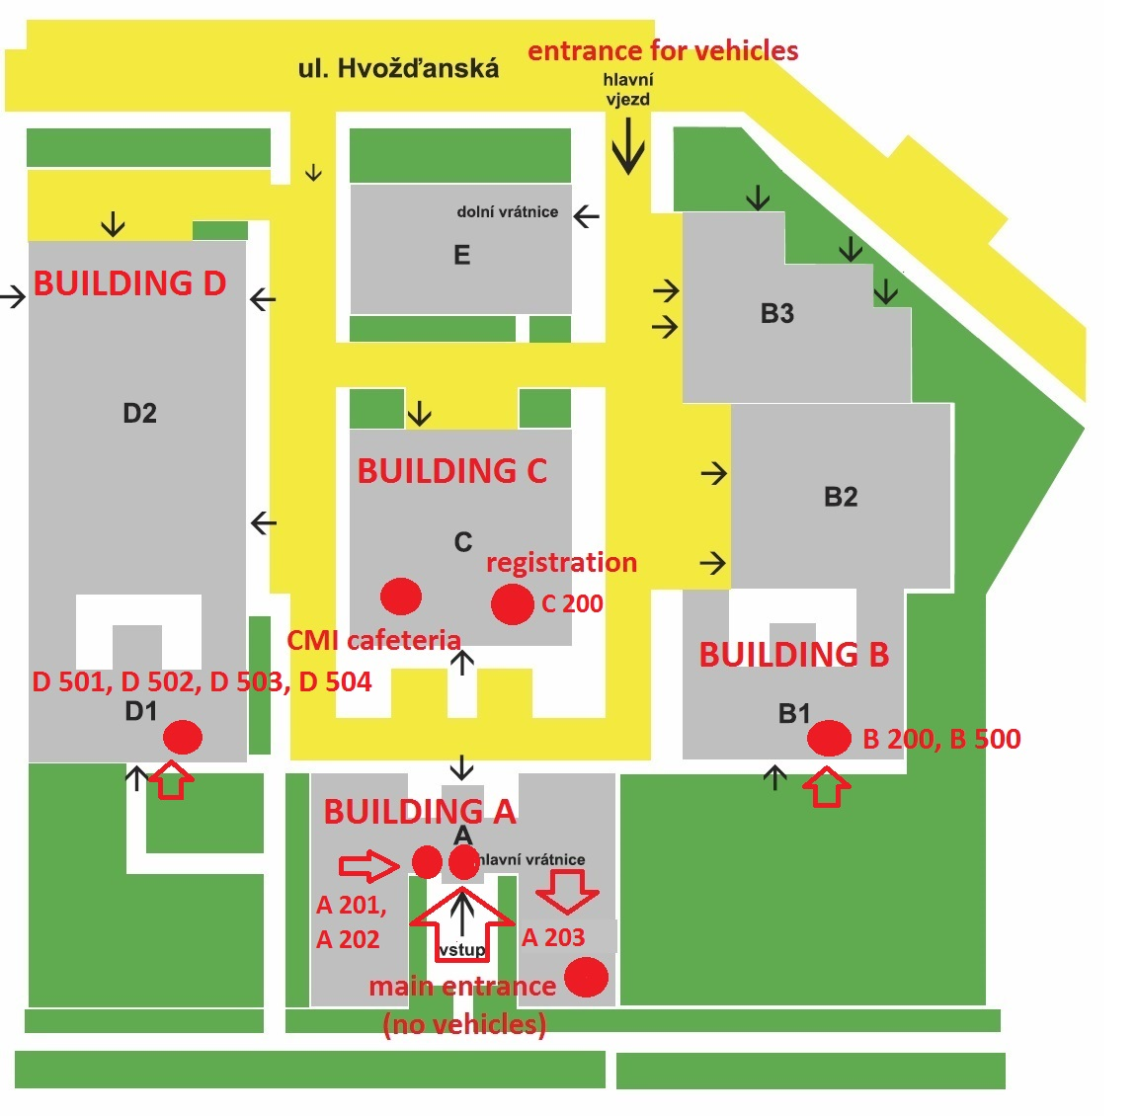
How to get to CMI
From the Václav Havel Airport Praha – two possibilities
- take the bus (special airport line) to the stop Hlavní nádraží (main train station), then cross to the metro (line C) and go to the stop Roztyly (direction Háje)
- take the bus no. 119 and go to the stop Nádraží Veleslavín, then take the metro there and go to the stop Muzeum (line A, direction Depo Hostivař), in Muzeum cross to the metro line C and go to the stop Roztyly (direction Háje)
Fare one way 32 CZK which is approximately 1,2 Eur.
By subway – from the main train station
If the participants arrive at the main train station (Hlavní Nádraží), they should take metro (line C, direction Háje) and go again to the stop Roztyly.
Fare one way 32 CZK which is approximately 1,2 Eur.
Accommodation
There are two hotels within approximately 15 minutes walking distance from the CMI:
Hotel Globus
Top Hotel
The hotels Top Hotel and Globus and also the building of CMI are situated within approximately 10 minutes walking of the metro stop Roztyly.
If the participants will stay at Top Hotel, it is slightly better to go one more metro stop from Roztyly called Chodov (metro line C).

