EMPIR Partnering Meeting

Time and place:
Monday 25th June – Tuesday 26th June 2018

Czech Metrology Institute, TESTCOM Praha, Hvožďanská Street 2053/3,

148 00 Prague, Czech Republic

Hosting: Czech Metrology Institute, Prague, Czech Republic

Monday 25th June 2018
From 8:30 | Registration: All Delegates (2nd floor, building C)  Please register early.
9:00 – 12:00 | Welcome and introduction.  A training session on EMPIR projects for all potential coordinators will be given by the MSU. (including 2 coffee/tea breaks)
12:00 – 13:00 | Lunch (CMI cafeteria, 2nd floor, building C)
13:00 – 13:30 | A training session on EMPIR projects for all attendees at the meetings will be given by the MSU.
13:30 – 18:30 | SRT discussions in various meeting rooms:
13:30 – 18:30 | building A, 2nd floor, room no. 201 | SRT-n09 Primary standards and traceable measurement methods for X-ray emitting
13:30 – 18:30 | building A, 2nd floor, room no. 202 | SRT-n11 Metrology for monitoring endocrine disrupting compounds under the Water Framework Directive
13:30 – 18:30 | building A, 2nd floor, room no. 203 | SRT-s11 Future photometry based on LED technology
13:30 – 18:30 | building A, 2nd floor, room no. 204 | SRT-n13 Improving validated methods for identification and quantification of titanium dioxide in nanoparticle mixtures
13:30 – 18:30 | building A, 2nd floor, room no. 205 | SRT-s20 New quantities for the measurement of appearance
13:30 – 18:30 | building B, 2nd floor, room no. 200 | SRT-n03 Flow metering of non conventional gases (biogas, biomethane, hydrogen, syngas and mixtures with natural gas)
13:30 – 18:30 | building B, 5th floor, room no. 500 | SRT-h17 Improved methods for activity measurement and distribution in patient for personalised nuclear medicine
13:30 – 18:30 | building C, 2nd floor, room no. 200 | SRT-h18 Metrology for drug delivery
19:00 – ......... | Dinner (CMI cafeteria, 2nd floor, building C, available from 18:30, closing time 23:00)

Tuesday 26th June 2018
9:00 – 12:30 | SRT discussions in various meeting rooms
12:30 – 13:30 | Lunch (CMI canteen, 2nd floor, building C)
The rooms will be available till 17:00 | SRT discussions in various meeting rooms

Contacts:
Contact person:
Ms. Karolína Weberová – kweberova@cmi.cz
phone: 00420 271 192 321
GSM: 00420 736 181 135
Other:
https://msu.euramet.org/calls.html
Map of CMI buildings:
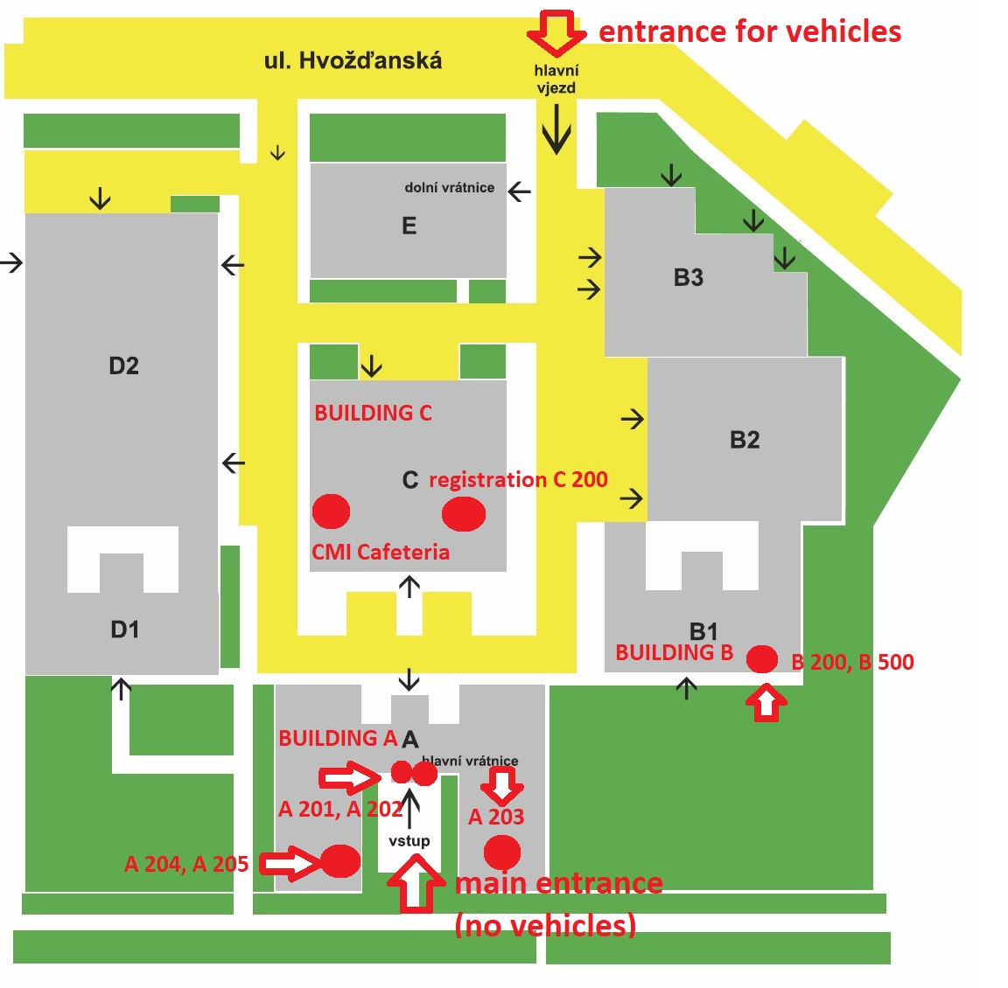
How to get to CMI
From the Václav Havel Airport Praha – two possibilities
- take the bus (special airport line) to the stop Hlavní nádraží (main train station), then cross to the metro (line C) and go to the stop Roztyly (direction Háje)
- take the bus no. 119 and go to the stop Nádraží Veleslavín, then take the metro there and go to the stop Muzeum (line A, direction Depo Hostivař), in Muzeum cross to the metro line C and go to the stop Roztyly (direction Háje)
Fare one way 32 CZK which is approximately 1,2 Eur.
By subway – from the main train station
If the participants arrive at the main train station (Hlavní Nádraží), they should take metro (line C, direction Háje) and go again to the stop Roztyly.
Fare one way 32 CZK which is approximately 1,2 Eur.
Accommodation
There are two hotels within approximately 15 minutes walking distance from the CMI:
Hotel Globus
Top Hotel
The hotels Top Hotel and Globus and also the building of CMI are situated within approximately 10 minutes walking of the metro stop Roztyly.
If the participants will stay at Top Hotel, it is slightly better to go one more metro stop from Roztyly called Chodov (metro line C).

